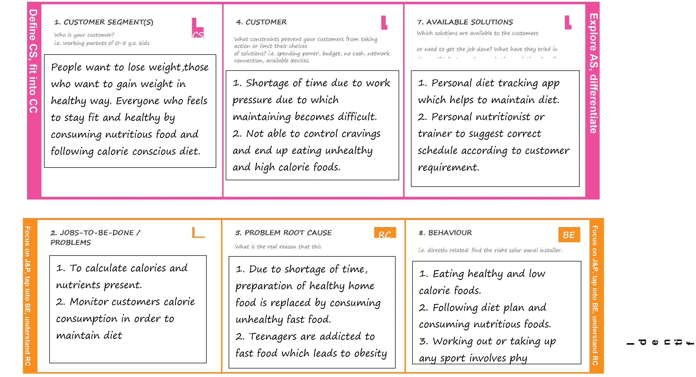Project Title:Nutrition Assistant Application Team ID: PNT2022TMID08258

